Building digital channels for fully personalised data experience

Annika Brauer is the Head of Data Technology Department at Statistics Estonia. She supervises the planning and execution of all technology related development projects. Her current portfolio consists of a thorough renewal of core statistical production systems as well as client-side applications, which involve an innovative approach to data sharing.
Annika has a Master’s degree in business information technology from Tallinn University of Technology.
E-mail: annika.brauer@stat.ee
Phone: +372 53 489984

Introduction
Statistics Estonia is glad to introduce the game-changing digital statistics Dashboards. The Dashboards are providing an innovative experience for the government and public authorities to support their data based decision-making.
Digital Dashboards are going to be released for every ministry, for their development plans and local government development plans, as well as for enterprises’ associations and private users.
The Dashboards are going to provide important and carefully selected indicators. The indicators are customizable by the user. Based on user’s interests and profile they can set priorities and switch on-off the displayed data modules.
The Dashboard layout is going to be fully visual and display different graph styles to describe the data. All data is based on Statistics Estonia public database (in phase 1).
The first Dashboard prototypes have received very positive user feedback and are expected to be launched in September 2019 at www.stat.ee.
Keywords: digital solution, data visualization, dashboards, personalized data, management tools

Background of the Dashboards project
Statistics Estonia is a government agency with the main task to provide public institutions, business and research communities, international organisations and individuals with reliable and objective information on the economic, demographic, social and environmental situation and trends in Estonia. Statistics Estonia as the main data competence centre in Estonia is also responsible for data governance in the country. The objective of Statistics Estonia is to become by 2022 the most effective and innovative producer of reliable and user-friendly statistics in Europe.
The results of the statistical activities of Statistics Estonia are published in the Statistical Database. Statistical data has been divided into subject areas. This distribution serves as a basis for the structure of the Statistical Database.
Statistical Database is used by all Estonian public institutions, business communities and individuals, as well as media companies looking for interesting data to support their stories.
Although our database is modern and well-structured, it lacks all possibilities to visualise the data. A user can read, filter and download the data in multiple ways, but cannot see the trends or make any assumptions. All data analysis and visualisation can only be done after the data has been downloaded.
However, data visualisation is very clearly helping people to read and understand the data. If we talk about the numbers and there is no trendline or graph to illustrate the data, we can often misunderstand what the data has to say.
For these clear reasons, the management Dashboards project was born in Statistics Estonia.
The Dashboards project started in late 2017 and the main objective was to start visualising the key data that would most affect the decision-making process in Estonian institutions. We started with visualising the data that we already have in our public database; of course, it would be possible to add third-party register data in the future.
The very first idea of the Dashboards was introduced to the national Government office, the Ministry of Social Affairs and Ministry of Economic Affairs and Communications. Several meetings were held to gather additional user needs and input, which all supported the need for the Dashboards project.
For example one of the first personalised dashboard will be built for the Ministry of Social Affairs, whose specific input was the following:
- The Ministry found most helpful that Statistics Estonia would list and prioritise the data that is most important to the managers of the Ministry
- The Ministry should be able to see and prioritise the selected data themselves
- All key indicators should be presented in a graphical way
- The data graphs should be divided into different Development plans to meet the needs of specific departments
Based on this input we finalised the needs and funcionalities for the 1st phase development.
We applied for funding from the European Structural Funds in spring 2018 and started preparations for the development work in summer 2018. The development contract with Netgroup OÜ was concluded in October 2018.

How do the Dashboards work?
First, we are going to execute the Dashboards for the Estonian Ministry of Social Affairs, Estonian Travel & Tourism Association and Estonian local governments. Other Dashboards will follow shortly during autumn 2019.
Dashboards are accessible via Statistics Estonia public website www.stat.ee by selecting the menu “Dashboards”.

- Authenticating
Dashboards can be used by using the authentication solution or using the quest account. An advantage of the authentication solution is that your personal settings will be saved for the next sign-in and you can customize your own data modules.
    - The Information System Authority’s authentication service TARA enables authentication with ID-card, mobile-ID or bank link. Additionally, it is possible to authenticate an eID user from an EU Member State.
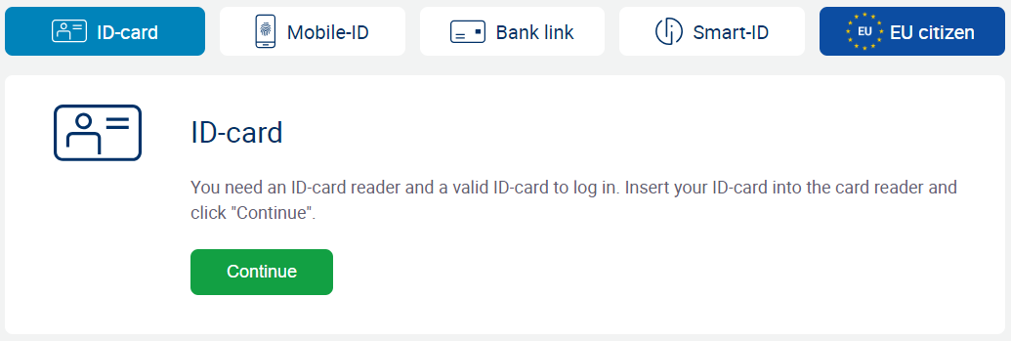

- Choosing the Dashboard
Once the user has logged in, it is possible to choose the desired Dashboard based on your interest. You can also make a city or county based selection to narrow your personalised view.
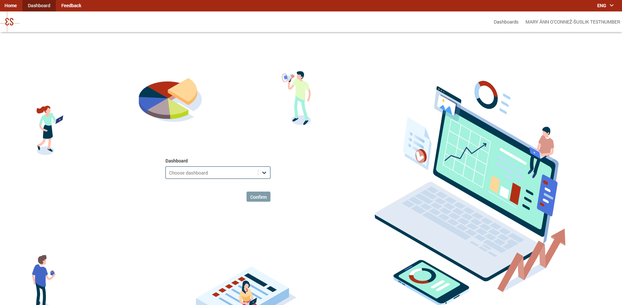

- Choosing the data modules
A user can choose the data modules from the menu drawer. The selections can be made by topics or by individual indicators. It is also possible to select everything at once.

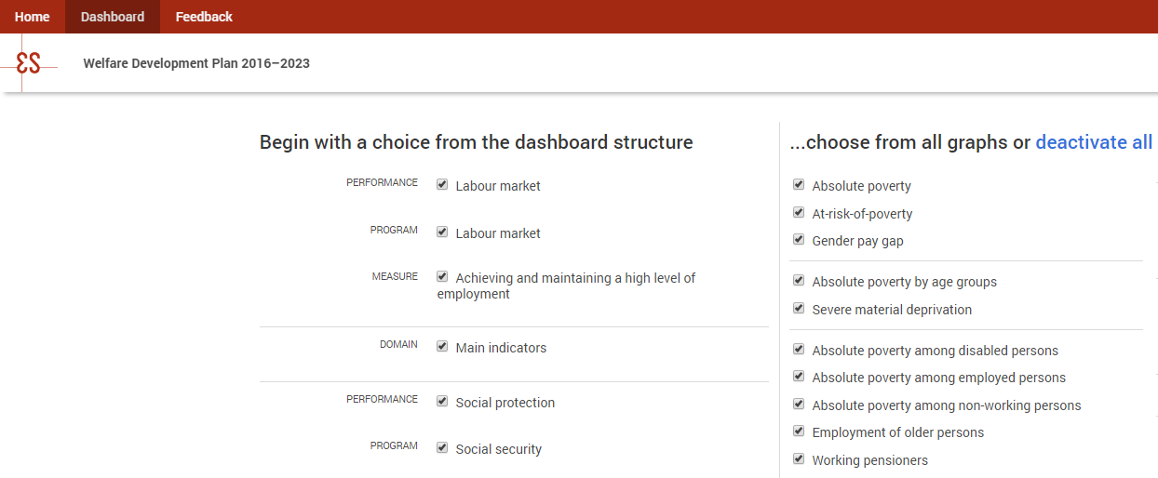

- Using the Dashboard
The main functions of the Dashboard:
- Displays chosen data modules
    - Each data module is a visualised graph of a statistics indicator
    - Drag-and-drop function for ordering the data modules
    - Deleting function for unsuitable data modules
    - Each data module shows the name of the topic

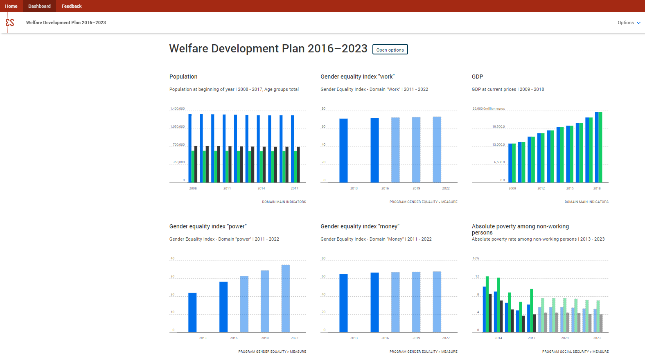
Detailed view of the data module:
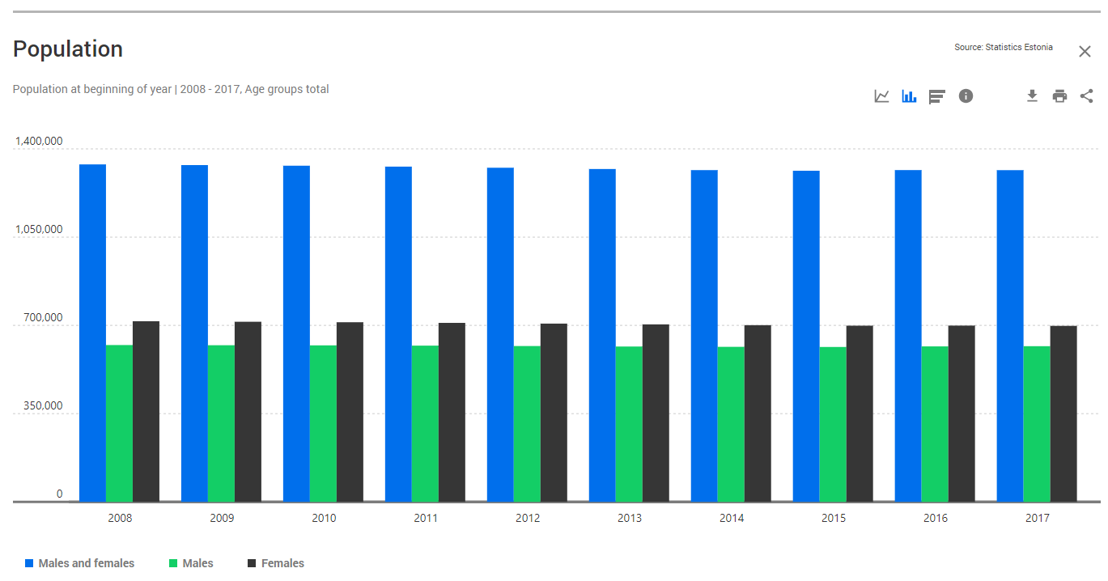

The detailed view of the data module enables:
- 10 different types of charts - max 4 shown by data module
  - Line Chart
  - Bar Chart
  - Column Chart
  - Stacked Column Chart
  - Donut Chart
  - Treemap
  - Radar Chart
  - Area Chart
  - Population Pyramid
  - Map

- Clickable legend and filters for personalisation of the chart – values can be selected and unselected

- User selections can be saved and reopened during the next visit

- Additional information
  - Definition and notes
  - Link to Statistics Estonia database and metadata
  - Date for data update

- Downloading
  - Personalised chart - picture file (JPG)
  - Personalised chart - data file (Excel, CSV)
  - Data and chart can be downloaded in Estonian or English

- Printing personalised data
  - Chart with heading

- Sharing the chart
  - URL to share the chart with personalised selections
  - Embedded code to embed the visualisation into another website
  - Facebook

Notifications for users:
    - Notifications for new data and new data modules on user Dashboard

Process for building a new Dashboard

To prepare a new Dasboard, our statistics and analysis departments should start the data preparation as early as possible. It might take around 6 months to carefully select and coordinate the data to meet the specific institution’s needs. It is not reasonable to display hundreds of data modules for a specific field and therefore it requires a strong prioritization from many counterparties to achieve the best result.
The prioritization process starts from listing all indicators of the specific field. Through many meetings and discussions with the experts from Statistics Estonia and leading managers from institutions we usually cut the list down to most important key indicators. It is good to get the list under one hundred key indicators per Dashboard.
Outcome of this prioritization gives an opportunity to all public and private sector managers to focus on what’s important – what are the trends of the specific interest area and how my institution/enterprise is compared to these trends?
In 2020-2022, we are planning to execute all 47 Estonian Government strategic development plans as Dashboards, in parallel with many enterprise associations’ and private persons’ Dashboards.

Technical background

Management Dashboards are built by Netgroup OÜ, one of the Estonian leading software companies.
The project is built on custom Java framework, which uses a Recharts javascript chart library built with D3 and React. Recharts library is an open source library, which enables us to freely share the visualisations with everyone interested in the country.
The data is provided via APIs from the main public database of Statistics Estonia.
Dashboards have their own custom built admin interface to create new Dashboards and data modules.
The whole project is hosted by the State Infocommunication Foundation, which provides a Governmental cloud solution.

